**A : To perform image filtering in frequency domain using ideal filter(low pass)**

clc;

clear all;

close all;

disp('FREQUENCY DOMAIN FILTERING');

a2=imread('C:\Users\admin\Desktop\GRAY.jpg');

a1=rgb2gray(a2);

a=double(a1);

[R,C]=size(a);

H=zeros(R,C);

N=C;

D0=input('Enter the cutoff frequency: \n');

for i=1:1:R

for j=1:1:C

D = [(i-N/2).^2+(j-N/2).^2].^0.5;

if D<=D0

H(i,j)=1;

else

H(i,j)=0;

end

end

end

B=fft2(a);

C1=fftshift(B);

CON=C1.*H;

BB=abs(ifft2(CON));

subplot(2,2,1);

imshow(a1);

title('ORIGINAL IMAGE');

subplot(2,2,2);

imshow(H);

title('FILTER RESPONSE');

subplot(2,2,3);

mesh(H);

subplot(2,2,4);

imshow(uint8(BB));

title('FILTERED IMAGE');

OUTPUTS :

%FREQUENCY DOMAIN FILTERING

%Enter the cutoff frequency:

%60

%FOR CLEAR IMAGE

%FREQUENCY DOMAIN FILTERING

%Enter the cutoff frequency:

%15

%FOR RINGING EFFECT

IDEAL FILTER

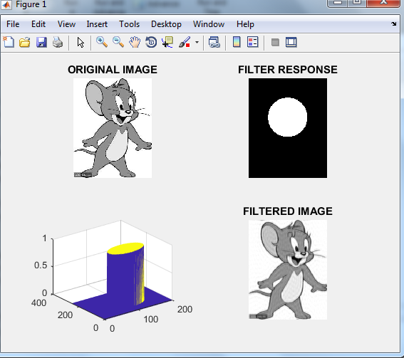

**B : To perform image filtering in frequency domain using Butterworth filter(low pass filter)**

clc;

clear all;

close all;

disp('FREQUENCY DOMAIN FILTERING');

a2=imread('C:\Users\admin\Desktop\GRAY.jpg');

a1=rgb2gray(a2);

a=double(a1);

[R,C]=size(a);

H=zeros(R,C);

N=C;

D0=input('Enter the cutoff frequency: \n');

n=input('Enter the order of filter:\n');

for i=1:1:R

for j=1:1:C

D = [(i-N/2).^2+(j-N/2).^2].^0.5;

H(i,j)=1/[1+(D/D0).^2*n];

end

end

B=fft2(a);

C1=fftshift(B);

CON=C1.*H;

BB=abs(ifft2(CON));

subplot(2,2,1);

imshow(a1);

title('ORIGINAL IMAGE');

subplot(2,2,2);

imshow(H);

title('BUTTERWORTH FILTER RESPONSE');

subplot(2,2,3);

mesh(H);

subplot(2,2,4);

imshow(uint8(BB));

title('BUTTERWORTH FILTERED IMAGE');

OUTPUT :

FREQUENCY DOMAIN FILTERING

Enter the cutoff frequency:

50

Enter the order of filter:

2

>>

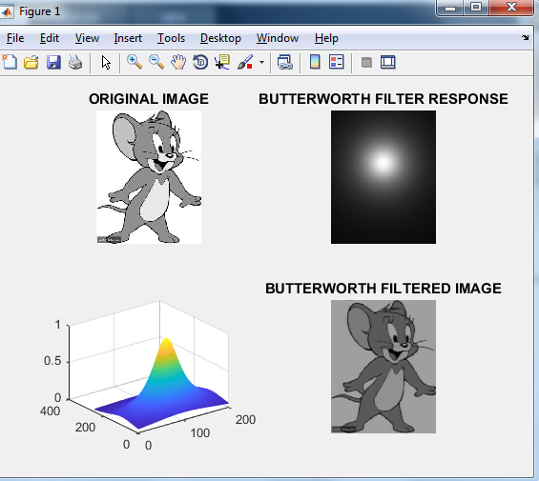

**C : To perform image filtering in frequency domain using Gaussian filter (low pass filter)**

clc;

clear all;

close all;

disp('FREQUENCY DOMAIN FILTERING');

a2=imread('C:\Users\admin\Desktop\GRAY.jpg');

a1=rgb2gray(a2);

a=double(a1);

[R,C]=size(a);

H=zeros(R,C);

N=C;

D0=input('Enter the cutoff frequency: \n');

for i=1:1:R

for j=1:1:C

D = [(i-N/2).^2+(j-N/2).^2].^0.5;

H(i,j)=exp(-1.*(D/D0).^2/2);

end

end

B=fft2(a);

C1=fftshift(B);

CON=C1.*H;

BB=abs(ifft2(CON));

subplot(2,2,1);

imshow(a1);

title('ORIGINAL IMAGE');

subplot(2,2,2);

imshow(H);

title('FILTER RESPONSE');

subplot(2,2,3);

mesh(H);

subplot(2,2,4);

imshow(uint8(BB));

title('FILTERED IMAGE');

OUTPUTS

FREQUENCY DOMAIN FILTERING

Enter the cutoff frequency:

50

>>

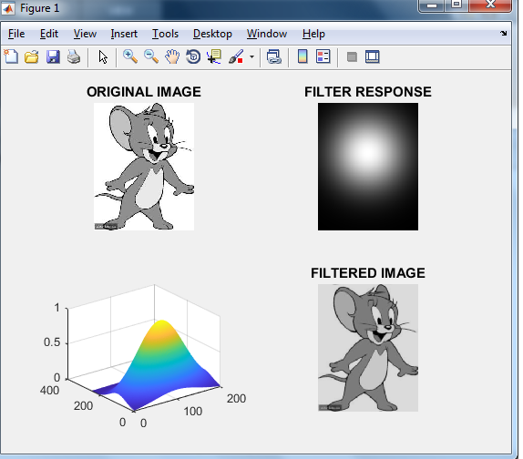

**D : To perform image filtering in frequency domain using ideal filter(high pass)**

clc;

clear all;

close all;

disp('FREQUENCY DOMAIN FILTERING');

a2=imread('C:\Users\admin\Desktop\GRAY.jpg');

a1=rgb2gray(a2);

a=double(a1);

[R,C]=size(a);

H=zeros(R,C);

N=C;

D0=input('Enter the cutoff frequency: \n');

for i=1:1:R

for j=1:1:C

D = [(i-N/2).^2+(j-N/2).^2].^0.5;

if D<D0

H(i,j)=0;

else

H(i,j)=1;

end

end

end

B=fft2(a);

C1=fftshift(B);

CON=C1.*H;

BB=abs(ifft2(CON));

subplot(2,2,1);

imshow(a1);

title('ORIGINAL IMAGE');

subplot(2,2,2);

imshow(H);

title('FILTER RESPONSE');

subplot(2,2,3);

mesh(H);

subplot(2,2,4);

imshow(uint8(BB));

title('FILTERED IMAGE');

OUTPUT :

FREQUENCY DOMAIN FILTERING

Enter the cutoff frequency:

50

>>

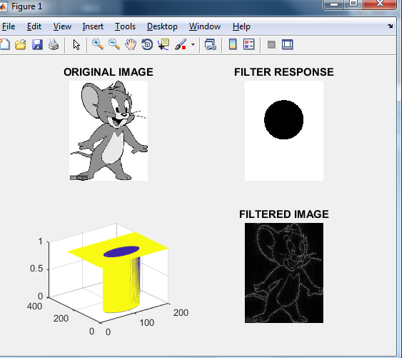

**E : To perform image filtering in frequency domain using Butterworth filter(high pass)**

clc;

clear all;

close all;

disp('FREQUENCY DOMAIN FILTERING');

a2=imread('C:\Users\admin\Desktop\GRAY.jpg');

a1=rgb2gray(a2);

a=double(a1);

[R,C]=size(a);

H=zeros(R,C);

N=C;

D0=input('Enter the cutoff frequency: \n');

n=input('Enter the order of filter:\n');

for i=1:1:R

for j=1:1:C

D = [(i-N/2).^2+(j-N/2).^2].^0.5;

H(i,j)=1-1/[1+(D/D0).^2*n];

end

end

B=fft2(a);

C1=fftshift(B);

CON=C1.*H;

BB=abs(ifft2(CON));

subplot(2,2,1);

imshow(a1);

title('ORIGINAL IMAGE');

subplot(2,2,2);

imshow(H);

title('BUTTERWORTH FILTER RESPONSE');

subplot(2,2,3);

mesh(H);

subplot(2,2,4);

imshow(uint8(BB));

title('BUTTERWORTH FILTERED IMAGE');

OUTPUT :

%FREQUENCY DOMAIN FILTERING

%Enter the cutoff frequency:

%50

%Enter the order of filter:

%2

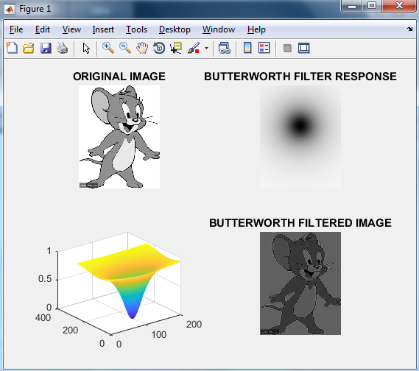

F: **To perform image filtering in frequency domain using Gaussian filter(high pass)**

clc;

clear all;

close all;

disp('FREQUENCY DOMAIN FILTERING');

a2=imread('C:\Users\admin\Desktop\GRAY.jpg');

a1=rgb2gray(a2);

a=double(a1);

[R,C]=size(a);

H=zeros(R,C);

N=C;

D0=input('Enter the cutoff frequency: \n');

for i=1:1:R

for j=1:1:C

D = [(i-N/2).^2+(j-N/2).^2].^0.5;

H(i,j)=1-exp(-1.*(D/D0).^2/2);

end

end

B=fft2(a);

C1=fftshift(B);

CON=C1.*H;

BB=abs(ifft2(CON));

subplot(2,2,1);

imshow(a1);

title('ORIGINAL IMAGE');

subplot(2,2,2);

imshow(H);

title('FILTER RESPONSE');

subplot(2,2,3);

mesh(H);

subplot(2,2,4);

imshow(uint8(BB));

title('FILTERED IMAGE');

OUTPUT

% FREQUENCY DOMAIN FILTERING

% Enter the cutoff frequency:

% 50

